Can Recurrent Neural Networks be used to Recognise patterns in Chaotic Systems such as the Stock Market?

Table of Contents
Can Recurrent Neural Networks be used to Recognise patterns in Chaotic Systems such as the Stock Market? 1
Abstract: 5
Chaotic Systems: 7
Neurons: 8
Activation Functions: 8
Layers: 10
Tensors: 10
Training: 11
Overfitting: 14
Recurrent Neural Networks: 14
Suitability of Neural Networks for Predicting Chaotic System Patterns: 16
Environment used to code my model: 16
Choice of Chaotic System: 17
Preparing the dataset: 17
Test Metrics: 18
Ethical considerations: 18
The use of Generative Artificial Intelligence in the research and execution of the artefact: 19
Designing my Neural Network Architecture: 19
Model: 19
Layers: 19
Regularisation Techniques: 20
Hypothesis: 20
Explaining the code: 20
Analysing the performance of my Neural Network: 25
Units: 25
Error Metrics: 25
Analysis: 25
Next steps: 26
Conclusion: 26
Bibliography 27
References 28

Table of Figures:
Figure 1: Illustration of a virtual neuron 7
Figure 2: Linear separation of pink dots from green dots 7
Figure 3: Non-linear separation of pink dots and green dots 8
Figure 4: Graphs of activation functions 8
Figure 5: Diagram of a deep neural network 9
Figure 6: An illustration calculating the dot products of matrices 9
Figure 7: Gradient Descent formula 10
Figure 8: 2D illustration of gradient descent 10
Figure 9: 3D illustration of gradient descent 11
Figure 10: Graph of Stochastic Gradient Descent 11
Figure 11: Illustration of Momentum on a graph 12
Figure 12: Illustration of a Recurrent Neural Network 14
Figure 13: Code snippet 1 19
Figure 14: Code snippet 2 20
Figure 15: Code snippet 3 20
Figure 16: Code snippet 4 21
Figure 17: Code snippet 5 21
Figure 18: Code snippet 6 22
Figure 19: Code snippet 7 22
Figure 20: Code snippet 8 23
Figure 21: Code snippet 9 23
Figure 22: Code snippet 10 23
Figure 23: Graph of Model Performance 24

Abstract:
In this paper I research the possibility that Recurrent Neural Networks (RNNs), specifically ones with Long Short-Term Memory (LSTM) architecture, can be used to recognise patterns in chaotic systems such as the stock market. First I give an overview of the stock market as a chaotic system, then I describe how neural networks work, and why neural networks might be suitable for this process. I go on to design a neural network, describing how I will prepare the training data and suitable model architecture. Finally I code my artefact, a LSTM and analyse its results for predicting stock prices and evaluate its suitability for this task.

Chaotic Systems:
Chaos theory is the study of complex systems where small changes in initial conditions can lead to vastly different outcomes. Chaotic systems are characterised by their sensitivity to initial conditions, meaning that even tiny changes can lead to unpredictable and divergent behaviours over time. A famous illustration of this concept is the 'butterfly effect,' which suggests that a butterfly flapping its wings in New Mexico could, through a series of complex interactions, potentially contribute to a hurricane in China.
The stock market is an example of a chaotic system. This is because it has so many variables contributing to fluctuations in prices. These range from market sentiment, natural disasters, social media influences and much more. These factors make the behaviour of the stock market highly unpredictable. Traditional methods employ complex mathematical models to account for numerous variables and to attempt to forecast market behaviour. But could there be another approach that doesn’t require examining each variable individually? Instead of treating it as a system of discrete variables, could we learn patterns from the data as a whole? I propose that neural networks are capable of this.
Overview of Neural Networks:
  - Neurons:
A neural network is a web of interconnected virtual neurons, organised into layers. Each neuron receives one or more inputs, applies weights to these inputs, and sums them to produce an output. This value is then passed through a non-linear activation function, see Figure 1.
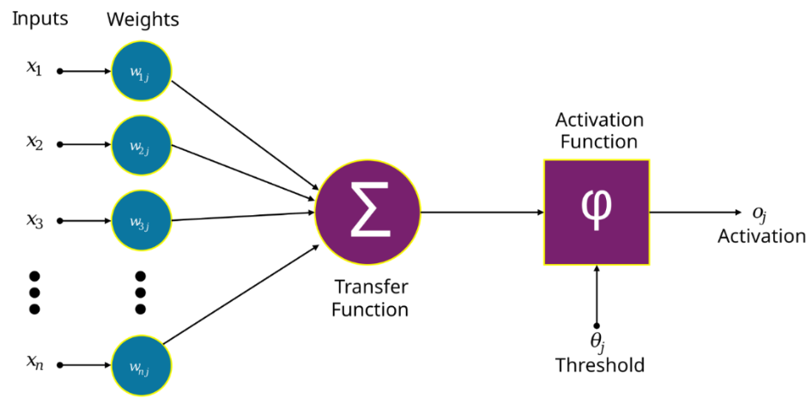
Figure 1: Illustration of a virtual neuron. Source: Funcs, Artificial Neuron Structure, https://en.wikipedia.org/wiki/Artificial_neuron#/media/File:Artificial_neuron_structure.svg
Each input to a neuron is a different number. It is multiplied by the weight (representing how important it is) corresponding to the neuron which received the input. The weighted inputs are then processed through a non-linear activation function and summed.
  - Activation Functions:
Without a non-linear activation function, neural networks would struggle to recognise patterns in non-linear data. For instance, a linear activation function might work well for tasks with linear separations, such as drawing a line to distinguish pink dots from green dots:
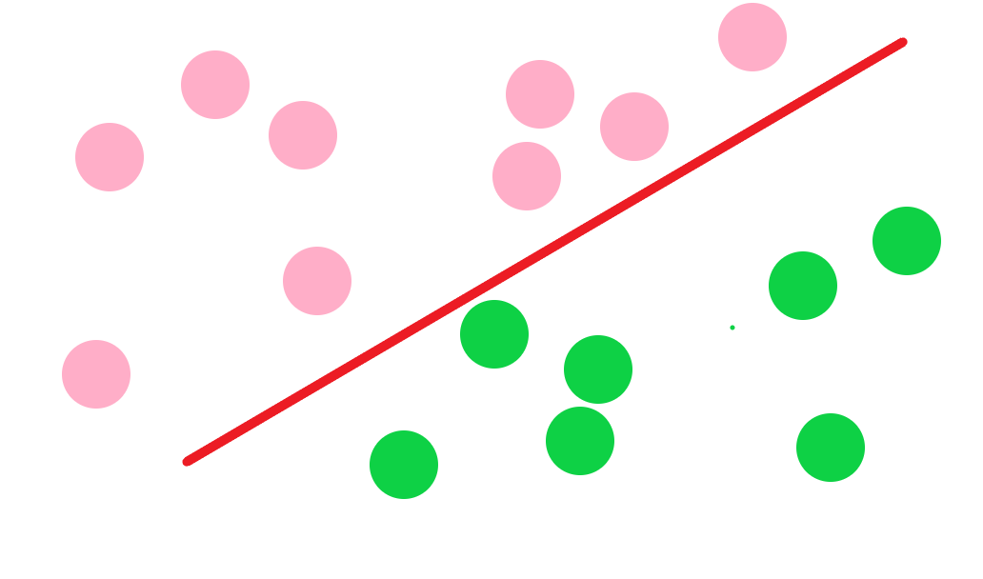
Figure 2: Linear separation of pink dots from green dots
However, as tasks become more complex, such as requiring the network to recognise non-linear patterns, a linear activation function becomes inadequate. In such cases, the neural network needs a non-linear activation function to capture and model these complex relationships effectively. Without it, the network would fail to properly identify non-linear boundaries, as illustrated below trying to draw a straight line rather than a non-linear curve to separate pink dots from green dots, when they are not in distinct areas.
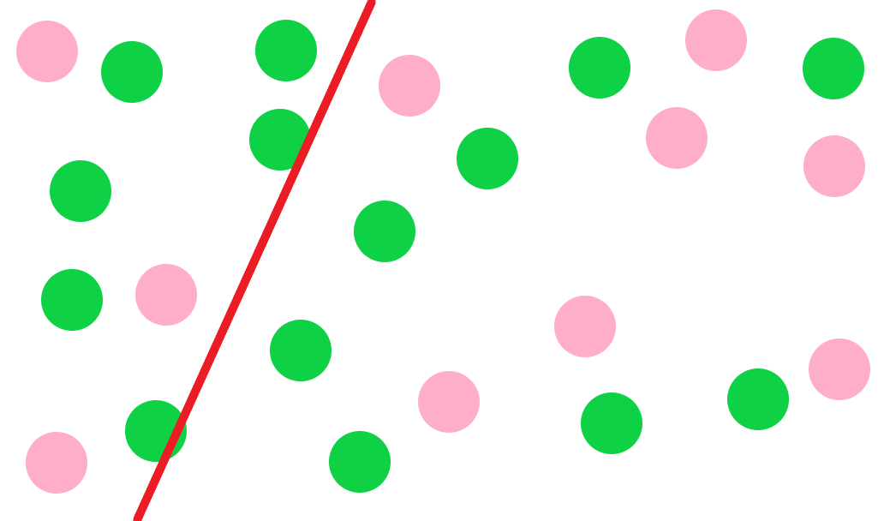
Figure 3: Non-linear separation of pink dots and green dots
See Figure 4 for graphs of some standard activation functions, the first three being non-linear.
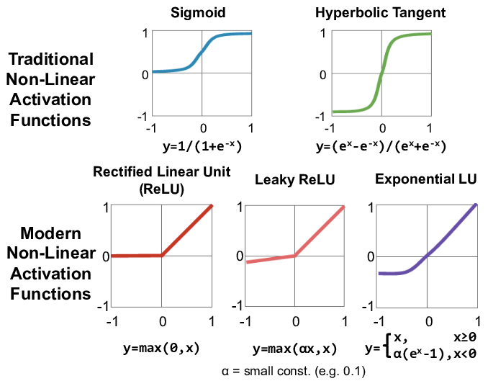
Figure 4: Graphs of activation functions. Source: Vivienne Sze, researchgate.net/figure/arious-forms-of-non-linear-activation-functions-Figure-adopted-from-Caffe-Tutorial-46_fig3_315667264

  - Layers:
Neurons organised into layers, an input layer, multiple hidden layers which do operations on the data inputted and an output layer to form a neural network:
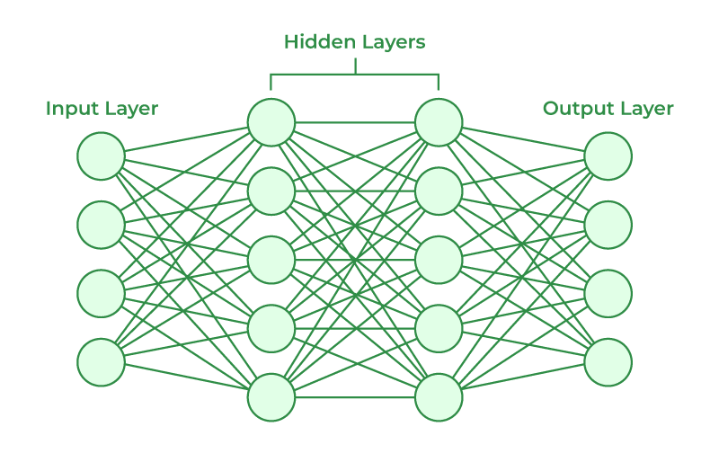
Figure 5: Diagram of a deep neural network. Source: GeeksForGeeks, Neural Networks Architecture, geeksforgeeks.org/artificial-neural-networks-and-its-applications
  - Tensors:
Each neuron and its parameters are packaged into a tensor (a multidimensional array of numbers) which then has operations applied to it. For example, the dot product between the input tensor and the weight tensor calculates the weighted sum for all neurons in a layer simultaneously. This approach, leveraging tensor operations, significantly speeds up the training and inference processes in neural networks. Instead of updating neurons individually, operations like matrix multiplication can be applied to entire layers at once allowing for efficient parallel processing.
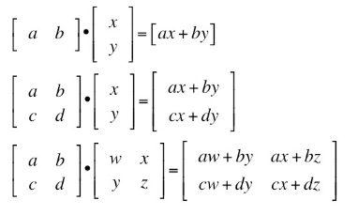
Figure 6: An illustration calculating the dot products of matrices

  - Training:
Neural networks (NN) are trained on data by feeding in training examples and comparing the network's output to the expected result. The difference between the predicted output and the actual output is known as the loss function. When training a neural network the weights of the neurons are adjusted to minimise the loss function. If the output is incorrect, the weights are adjusted to reduce the error; if the output is correct, the weights are adjusted to reinforce the correct prediction. The amount the weight is adjusted by is proportional to how far the predicted output is from the expected output. Finding the difference between outputs is performed through each layer in a process known as backpropagation. It starts at the output, looking at the inputs to that, then goes back a layer looking at the inputs to that neuron and repeats going back through the whole NN finding the differences between inputs and outputs.
Backpropagation calculates the gradient of the loss function with respect to the network's weights by applying the chain rule of calculus through each layer of the network. Once that loss function has been calculated it is minimised using a numerical method called ‘Gradient Descent’. Gradient descent navigates the loss function’s surface to find a local minimum cost. It does this by adjusting the weights in the opposite direction of the gradient, moving an increment down each time. Similar to a ball rolling down a slope.
This is the formula for gradient descent, where Δv (delta v) represents the change in the networks weights, η (eta) represents the learning rate which is how large the step size of each iteration moving towards the minimum, and ∇C (nabla C) which represents the gradient of the loss/cost function with respect to the networks weights.
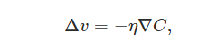
Figure 7: Gradient Descent formula
This is a graph of the process of gradient descent being applied to a 2D graph, where it moves in the opposite direction to the gradient of the graph, multiplied by the learning rate. In this scenario the learning rate decreases as it converges to minimum value.
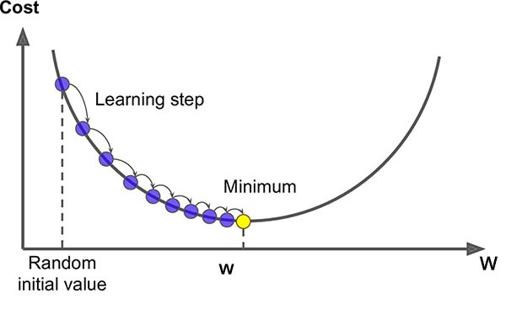
Figure 8: 2D illustration of gradient descent. Source: Rishi Zirpe, blog.gopenai.com/understanding-of-gradient-descent-intuition-and-implementation-b1f98b3645ea
In reality though, with neural networks the graph being traversed will not be a 2D graph but rather an N-dimensional graph where N is equal to the number of parameters the model has (parameters being but not limited to the number of weighted neurons). This can be hard to visualise as neural networks used in cutting-edge technology can have incredibly high number of parameters, GPT-4 has over 1.8 trillion parameters.
See Figure 9 for gradient descent being applied to a 3D graph.
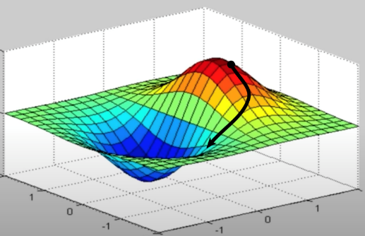
Figure 9: 3D illustration of gradient descent. Source: Questions and Answers in MRI, Loss function represented in 3 dimensions, mriquestions.com/back-propagation.html
Gradient descent provides an approximation of the minimum value by finding a good local minimum rather than the global minimum. For neural networks with very large numbers of parameters, gradient descent can get trapped in local valleys. Finding the global minimum analytically is infeasible because it would require calculating billions, possibly trillions, of partial derivatives. Gradient descent significantly reduces computational costs while still identifying sufficiently optimal local minimum. However, for large neural networks, even gradient descent can be computationally expensive. As we will now explore, modifications of the standard gradient descent algorithm are often used to improve efficiency.
The simplest modification would be Stochastic Gradient Descent (SGD). Unlike vanilla gradient descent, which computes the gradient for the entire dataset, SGD updates the model parameters using one random data point at a time. This not only helps prevent overfitting (which we will discuss shortly) but also speeds up the training process, as it operates in a lower-dimensional space by considering fewer data points per iteration. When plotted it may look like a ‘drunk’ version of gradient descent, but as it is the same dataset, should still converge at a local minimum.
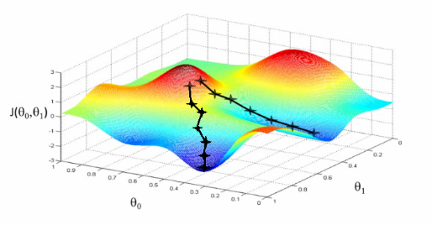
Figure 10: Graph of Stochastic Gradient Descent. Source: Gradient Descent Algorithm, Society of AI, https://societyofai.medium.com/gradient-descent-basics-and-application-1cef98179ee6
Another modification is ‘batch’ gradient descent, where rather than calculating the gradient of the whole dataset, it is only calculated for batches. This is often used in conjunction with SGD, rather than only calculating the gradient of one random piece of data at a time.
A more advanced modification, and the optimisation algorithm I will use in my artefact, is Adaptive Moment Estimation (ADAM), a form of Stochastic Gradient Descent. It is built on a combination of two techniques, the first is ‘Momentum’. Momentum allows the search to build inertia, so it doesn’t get caught up in noisy bits of the graph. Below is a drawing I did to illustrate the difference between vanilla gradient descent on the left and momentum on the right. Gradient descent would get caught up in the first valley and not progress, whereas momentum would have the speed to carry on through the first valley and then get caught up in the second which is deeper.
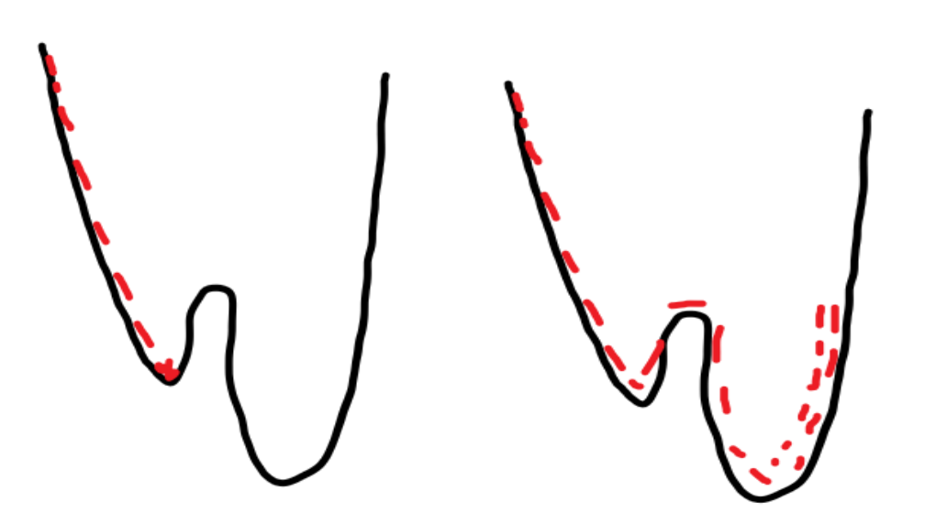
Figure 11: Illustration of Momentum on a graph
So momentum is more likely to find a better local minimum, as it can coast through flat areas of the graph and is less likely to get caught up in the first trough it finds.
The other technique that ADAM uses is adaptive learning rates, which means it adjusts the size each step based on past progress. This is useful since sometimes smaller steps will avoid overshooting a local minima, while at other times bigger steps speed things up. ADAM keeps track of how steep or bumpy the path has been for each part of the problem and uses that information to decide the step size. This makes it better at handling situations where the path is noisy, helping it find the best solution more efficiently. For large and convoluted datasets like the stock market ADAM requires less memory and is more efficient, making it a suitable choice as an optimiser for my artefact.

  - Overfitting:
As mentioned earlier a Neural Network can become overtrained, leading to a phenomenon known as 'overfitting.' This occurs when the network is trained for too long on the same dataset. As a result, instead of learning the general patterns of the data, the neural network essentially memorises the specific dataset it was trained on. When presented with new data, it struggles to make accurate predictions because it applies the same learned patterns from the original dataset, rather than generalising to new inputs.
To combat overfitting and ensure the neural network can generalize to other datasets of the same type, regularization techniques are employed. One such technique is ‘dropout’, where during training a random amount of neurons is “dropped” (set to zero) in each forward and backward pass. This is to prevent the network becoming overly reliant on a specific set of neurons.
To address overfitting, another important technique is splitting the dataset into three parts: training data, validation data, and test data. The training data is used to train the model using gradient descent. After each training epoch, the validation data is used to assess the model's performance on unseen data and adjust hyperparameters (such as the learning rate; see Figure 7). This helps ensure that the network is not overfitting to the training set. If the model performs poorly on the validation data, adjustments are made to improve generalization.
Once the model is fully trained, the test data—which has remained completely unseen by the network during training and validation—is used to evaluate the final model's performance. This comparison between the test data's actual values and the model's predictions provides a clear measure of how well the model generalizes to new, unseen data.
I will use dropout in my neural network, the other regularisation technique that I will utilise is ‘Early Stopping’. Early Stopping means, when looking adjusting the hyper parameters looking over the validation dataset, if validation loss does not see any improvement for a number of epoch (e.g. 10), the specific number is known as the patience, then training will stop, and the weights will be restored to the best performing weights during validation training.
  - Recurrent Neural Networks:
So far, we have only discussed Feedforward Neural Networks (FNNs), where data flows in one direction from the input layer to the output layer. While this is suitable for many tasks, it is not always appropriate for tasks that involve sequences or patterns with temporal dependencies. FNNs have a fixed input size, meaning they can only process inputs of a size equal to the number of input neurons they have. Additionally, FNNs lack memory, meaning they do not retain information from previous inputs.
Recurrent Neural Networks (RNNs) address these limitations by feeding the output of the network back into the hidden layers, creating a form of short-term memory. This allows RNNs to effectively handle sequential data and recognize patterns over time. Consequently, RNNs can accommodate variable input sizes and capture temporal dependencies, which makes them well-suited for tasks involving time-series data or sequences.
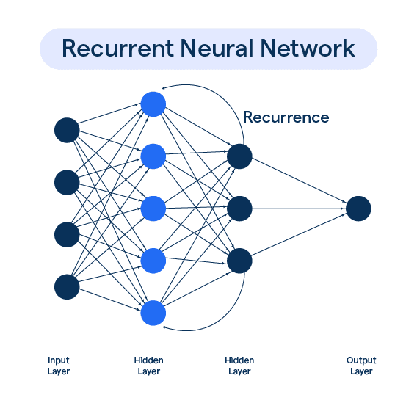
Figure 12: Illustration of a Recurrent Neural Network. Source: BotPenguin, https://botpenguin.com/glossary/recurrent-neural-network
However, for time-series forecasting with stocks, a basic RNN architecture is often insufficient because RNNs struggle to retain information over long sequences. This is largely due to a problem known as the vanishing gradient. During training, RNNs rely on backpropagation through time (BPTT) to update the weights of the network. In this process, the gradients—values used to adjust the weights—are propagated backward through the network's layers.
The vanishing gradient problem occurs when these gradients become extremely small as they are passed through each layer, especially in deep networks (many layers) or sequences with long time dependencies. Since the gradients shrink exponentially, the early layers (or earlier time steps in the case of RNNs) receive gradients so small that they are unable to update their weights effectively. As a result, the network 'forgets' crucial information from earlier in the sequence and struggles to learn long-term dependencies.
To overcome this, I will use a more advanced RNN architecture called Long Short-Term Memory (LSTM). LSTMs solve the vanishing gradient issue by using special mechanisms, such as input, forget, and output gates, to control the flow of information. These gates allow the model to maintain a more stable flow of gradients during training, enabling it to store and retrieve important information over long periods of time.
In essence, neural networks are powerful tools for discovering the underlying function that relates inputs to outputs, and LSTMs are particularly well-suited for capturing patterns over extended sequences.

Suitability of Neural Networks for Predicting Chaotic System Patterns:
Patterns in chaotic systems essentially don’t have one function but many different functions convoluted into one, as they have so many variables, it can be very hard or even impossible to predict the general function. Traditional methods, like stochastic calculus, for predicting patterns in chaotic systems like the stock market look at each of these subfunctions independently. Neural networks however process the data holistically, encoding different variables into a single convoluted function. This allows the model to predict the outcome of a single, integrated process rather than having to separately predict the outcomes of numerous individual processes. Therefore, I believe neural networks are well-suited for predicting stock prices, as they can capture the intricate interdependencies of the many variables in the stock market within a single function, unlike traditional regression models, which cannot account for such complexity. I will produce evidence for this by designing a Recurrent Neural Network for my artefact to predict stock prices and then analyse its performance compared to other models.

Environment used to code my model:
Language used: Python
Libraries used: TensorFlow, yfinance (yahoo finance), numpy, pandas, matplotlib, sklearn
When deciding how to implement my neural network model, I considered three programming languages: Python, Java, and R.
I did not choose Java because, although it is a powerful object-oriented language, it is less commonly used for deep learning and lacks the same level of community support and pre-built libraries that Python offers. Additionally, Java is more verbose, making rapid development slower and more cumbersome for a project of this type.
I did not use R because it is primarily geared towards statistical analysis and data visualisation, and although it has some support for machine learning, it is not as well-suited for building and training deep learning models.
I chose Python because it is the industry standard for deep learning projects. It has a vast ecosystem of libraries such as TensorFlow, NumPy, and scikit-learn, which streamline the development process. I am also already proficient in Python, which allowed me to focus more on the logic and design of the neural network rather than learning a new language.
Python is also a frontier language used in deep learning as it provides features such as automatic differentiation, speeding up training through backpropagation, and fast matrix multiplication enhancing both inference and training speed.
I will use the TensorFlow library as it allows neural networks to be designed quicker, adding a layer of abstraction, so it does not have to be coded from scratch, but rather allows predefined features to be added. I considered TensorFlow’s competitor, PyTorch, but decided against it as both books I was reading (Raschka, 2019), (Nielsen, 2019) used TensorFlow, so I was more familiar with it.
I will use Visual Studio Code (VSC) as my Integrated Development Environment (IDE), to write my code. Alternatives to VSC would include Jupyter Notebook, which shows results as you code. I chose VSC as I am already familiar with it for other projects I have coded in the past, so it makes more sense to use it to focus on the core problem at hand, rather than being confused learning a new IDE. VSC colour codes different syntax, making it easy to read. It also allows me to run the code in the editor, for quick testing/debugging.
For accessing the data, preprocessing and processing it I will use standard libraries. I will use Yahoo Finance to download historical stock market data. I will use NumPy to perform linear algebra operations. I will use Sci-Kit Learn to normalise the data and produce test metrics. Pandas will be used to handle the data, adding it together, access different indexes etc.

Choice of Chaotic System:
In my project, I chose the stock market as the chaotic system to study because it’s highly unpredictable, with many factors like market sentiment and news affecting prices (Page 6). This made it an interesting challenge for testing whether neural networks can spot patterns. I considered using weather data, which is also chaotic due to its sensitivity to small changes, like temperature or wind. However, stock market data was easier to access through free sources like Yahoo Finance, and also provided a very clear objective metric to predict, the closing price. The stock market also provided a clear dataset of daily prices, which suited my model’s time-series approach (Pages 13–14).

Preparing the dataset:
I will train my model on the S&P 500, an index which tracks the stock performance of 500 of the largest companies in the United States. I will access the historical data using the Python library ‘yfinance’ which allows historical stock data to be downloaded from the Yahoo Finance. The data set used will have 20 years of historical data from 2000 – 2020. This will allow the model to predict the trends in 2020, while having the actual data to compare how accurate the models predictions are.
I will have a 70%, 20%, 10% split for the training set, validation set, and test set, respectively. This is because stock data is often noisy and more nuanced, so a larger training set will be appropriate to capture the complexity of the stock market’s behaviour. Having a larger dataset will allow long term dependencies to be understood better by the model. Stock market data is highly variable having a larger validation set ensures the model performs well on data that was not seen during training. I will use a smaller amount of data while still sufficient to test the reliability of the model. The data used for the training set will be the most recent 10% out of the stock market so the model can be tested with unseen data and see how well it can observe future trends.
As the data is time-series based, a time ordered split will be used, the data will be chronologically stored to prevent information from the future (ahead of the point of prediction) influencing predictions.
Once the data has been downloaded and split it will be normalised, which means to scale the data to a given range (in this case between 0 and 1) by finding the maximum and minimum data points then transforming all the datapoints to fit in this range using the scikit learn library. This is helpful because otherwise there can be a loss in accuracy when larger numbers dominate the models attention. It also often leads to better convergence for models which use gradient descent (such as mine), when data is unscaled it can take longer to find a minimum.
As I will be running my code on my personal laptop, it will only be able to be trained on one stock index, and given 20 years of historical data. In theory, to be very successful or even potentially useful in a commercial environment it would need a far more rich set of data.

Test Metrics:
My model will use mean squared error (MSE) as a loss function. At the end of testing it will output the following metrics: Mean Absolute Error, Mean Squared Error , Root Mean Squared Error to give an idea on how close it is to the actual data.
I will plot the actual data, the test data, against what the model predicted on the same graph to give an idea of how accurate it was. I will also plot 100 days of actual data before the predictions to give an idea of what the market looked like before the model started making predictions

Ethical considerations:
The data used to train my model will all be in the public domain, I will not use any proprietary data and will adhere to privacy and intellectual property laws.
My model may exhibit bias due to being trained exclusively on a single stock index that represents the largest 500 companies in the U.S. As a result, its accuracy may be limited when applied to other markets, such as the London Stock Exchange, smaller companies, more volatile markets like NASDAQ, cryptocurrencies, or international stock markets such as the Shanghai Stock Exchange. Its scope is primarily constrained to more stable U.S.-based companies, and it may not generalize well to different market conditions or regions
Reliance on the model could be risky for one’s financial assets. Instead the value of the model comes from educational value, to understand better how neural networks can be used to recognise patterns in chaotic systems, and their capability to predict trends in the stock market.

The use of Generative Artificial Intelligence in the research and execution of the artefact:
I used OpenAI’s ChatGPT and Anthropic’s Claude models to help research my artefact asking questions on what models might be suitable, to fact check statements I write, to find what libraries may be suitable for the task, and to help spot errors in my code.

Designing my Neural Network Architecture:
  - Model:
My model will be a Long Short-Term Memory model as discussed on page 14. It will be built upon the sequential API in TensorFlow Keras which allows stacking layers sequentially as the task requires a flow of data from input to output. Since it is an LSTM the activation function (see page 6-7) used will be tanh for hidden states and sigmoid for gates.
I will use the ADAM optimiser (discussed on) to train my network, as it is efficient for large and noisy datasets like the stock market.
  - Layers:
The first LSTM layer has 50 units to learn temporal patterns in the time-series stock market data fed into it, it will process the data and store long term dependencies then output it to the next layer.
The second layer is a dropout layer, which prevents overfitting by randomly deactivating 20% of neurons during training, as discussed on page 14. This is useful as stock market data is very noisy, dropout ensures the model generalises for unseen data.
The third layer is another LSTM layer, with 50 units to ensure consistency with the first. I chose 50 because it was the most my computer could handle while running at a good speed. This layer, unlike the first, does not output the sequence, it only outputs a single vector representation. This is because it builds on the patterns learnt by the first LSTM layer and extracts the higher level temporal features.
The fourth layer is a second dropout layer. This further regularises the network and prevents overfitting.
The final layer is a single dense output layer. A single neuron is used to produce a continuous value. It extracts all the features from the preceding layers and outputs the predicted closing price of the stock market on that day.
  - Regularisation Techniques:
I will use early stopping and drop out (discussed on page 13) to address overfitting.

Hypothesis:
I predict my model will not be very accurate after a small amount of time, for example more than 2 days, as the stock market is inherently noisy and my model is not trained on a very large dataset due to physical limitations. I predict it will be able to spot basic trends, for example if it was going up yesterday it will go up today as well, if it went down yesterday it will go down today.

Explaining the code:
I will now explain the code of my coded artefact.
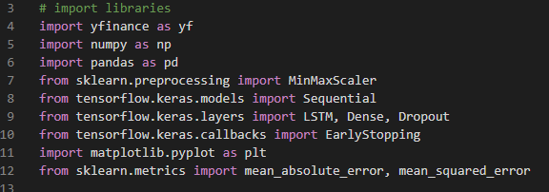
Figure 13: Code snippet 1
First the relevant libraries that were discussed on Page 14 are imported.
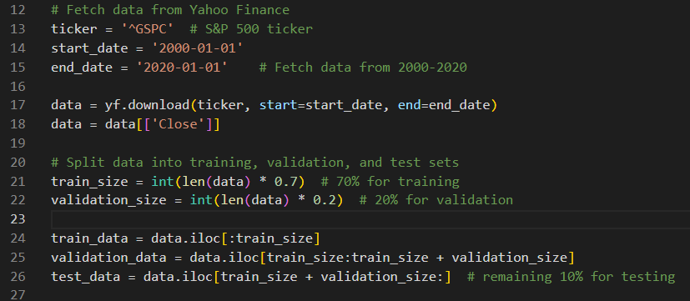
Figure 14: Code snippet 2
The historical stock market data of the S&P500 between the years 2000 and 2020 is downloaded using yfinance. It is then split into 70% training data, 20% validation data and 10% for testing, each set being stored in its own array.
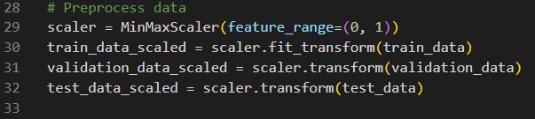
Figure 15: Code snippet 3
The data is then preprocessed by using a minmax scaler between 0 and 1, so the maximum and minimum values are transformed to 1 and 0, and applying into the training, validation and testing dataset.
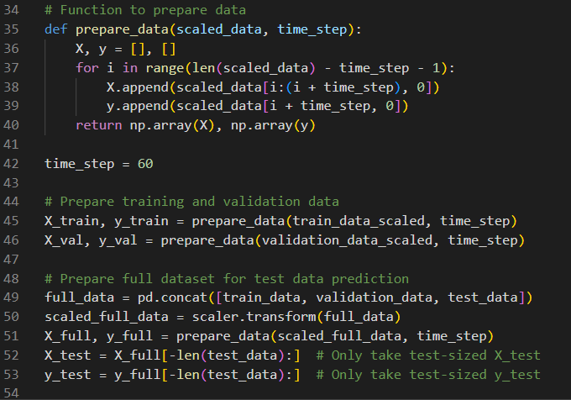
Figure 16: Code snippet 4
The data is then prepared. First a function is then defined called prepare_data, which takes the parameters “data” (which would be the data to be processed) and “time_step” (which defines the number of lookback steps for training the model). It then defines the numpy arrays X and y, where X stores the inputs for the model and y stores the corresponding outputs. The data is then split into sequential inputs so the model can learn temporal dependencies. It iterates through the scaled data adding windows the size of the time_step of the scaled data to X, and adds the value that directly follows that window to y. This way when the model is being trained it will look at an input window of 60 days the price of the stock market, make a prediction on the price of the next day, then compare its prediction with the actual price the next day. This process will then repeat.
After the function is defined, the time step is defined to be 60 days, then the function is used on the training and validation set. Once this is done all the datasets are combined to be used when making predictions.
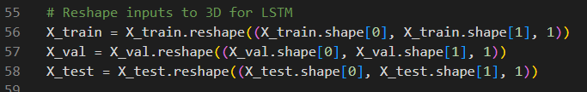
Figure 17: Code snippet 5
The datasets being used as inputs for the model are then reshaped to a 3D tensor. This is since for the model to process the data it needs to know 3 attributes. The first is the batch size, which determines how many timesteps (days) there are in the dataset. The second is the number of timesteps, in this case being 60, as the dataset is broken into sequences of 60 days. Each time the model makes a prediction it looks back at the past 60 days. The third is the features, and there will only be 1, the closing price of the S&P 500 on the given day.
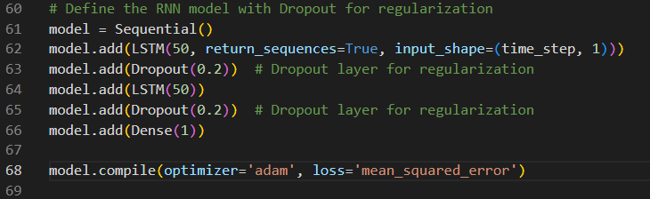
Figure 18: Code snippet 6
Here I define the architecture of the model.
First the model is declared as sequential. An LSTM layer with 50 nodes is then added to the model, it will return the sequence to the next layer, and it will take the following parameters: “time_step” which stores the number of days, and then a 1 to signify only attribute is monitored, the closing price.
A dropout layer is then added, which drops 20% of the neurons – turning them to 0. This is a regularisation technique (discussed on page 14). It is added so the model does not memorise the dataset but is able to generalize for unseen data.
Another LSTM layer and dropout layer is added, then a dense layer which will output a single number, the closing stock price for that day. The model is then compiled using an adam optimizer and MSE as a loss function.
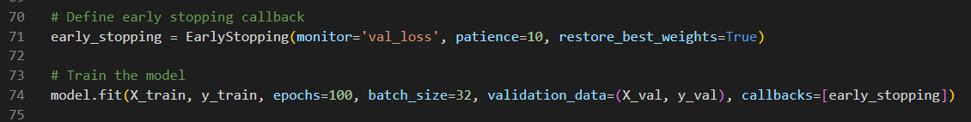
Figure 19: Code snippet 7
Another regularization technique is then implemented called “Early Stopping” discussed on page 13.
The model is then trained for 100 epochs, each batch size being 32, so 32 pieces of data are used to calculate the gradient each time, X_val and y_val are fed in as the validation data, and early stopping is used as a callback.
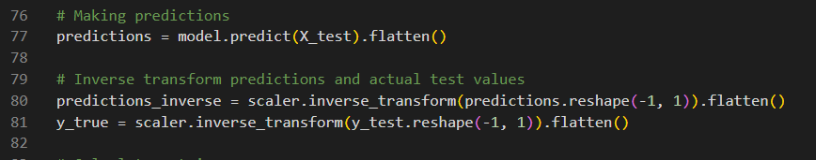
Figure 20: Code snippet 8
The model then makes predictions based on the test data and stores them to an array named “predictions”. As these predictions were transformed into a format for the model to understand, an inverse transformation is then applied to reshape the data so it can be plotted on a graph that would give us meaningful data.
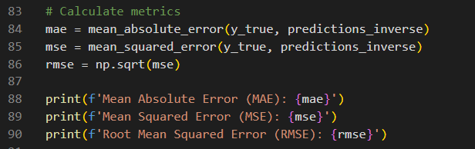
Figure 21: Code snippet 9
Test metrics are then calculated by comparing the actual values and the predicted values.
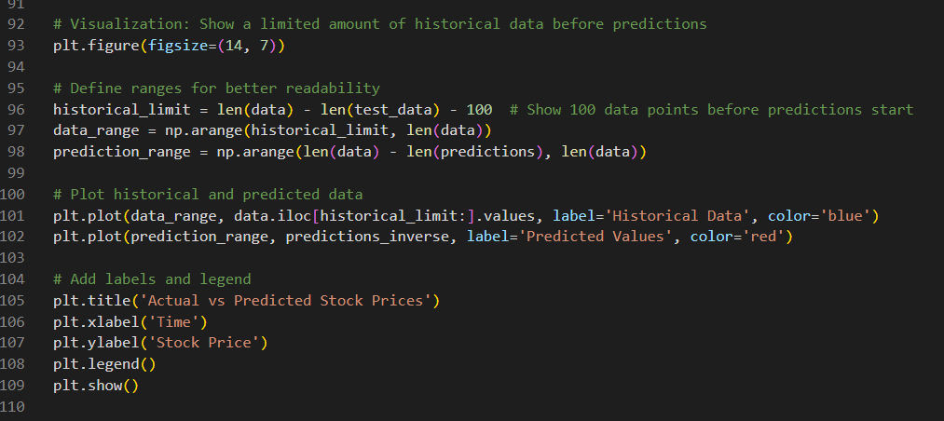
Figure 22: Code snippet 10
The data is then plotted. A graph is made, first 100 historical datapoints before the predictions start is plotted to provide context. The historical data is then plotted in blue starting 100 datapoints before the last prediction and ending at the last prediction, and the predicted datapoints are plotted in red. The axis are then labelled.

Analysing the performance of my Neural Network:
Below is the output from my Neural Network:
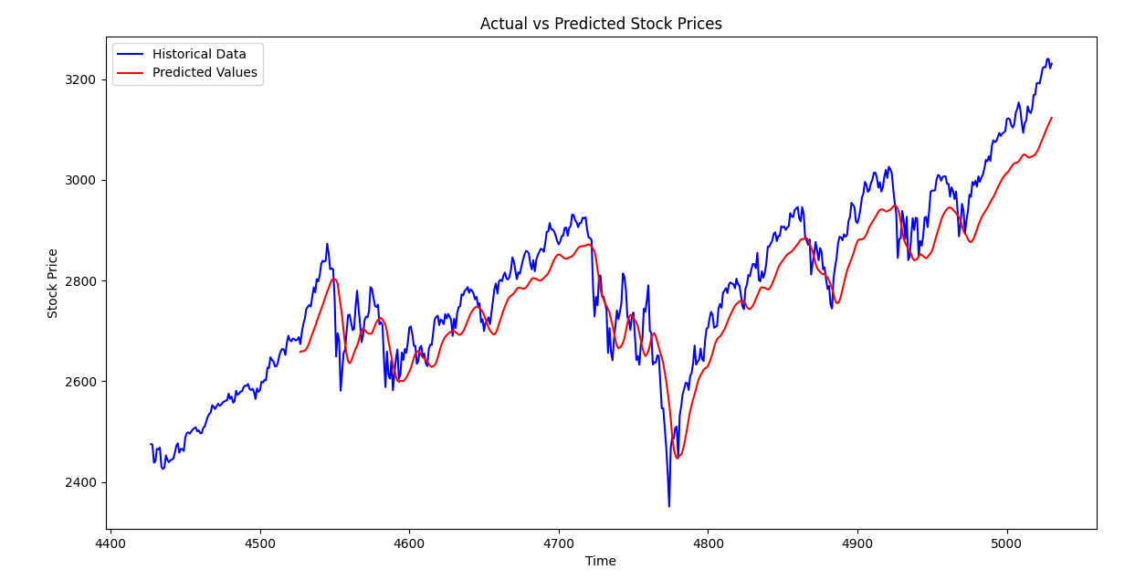
Figure 23: Graph of Model Performance

Units:
- x-axis: days since January 1st 2000
- y-axis: stock price in USD of the S&P 500

Error Metrics:
Mean Absolute Error (MAE): 55.7
Mean Squared Error (MSE): 4093
Root Mean Squared Error (RMSE): 63.9

Analysis:
The predictions lag behind, showing it knows if a stock has been going up, it is likely to go up tomorrow, and if it has been going down, it is likely to go down tomorrow. However it cannot work out when it will go up or down independently, showing it fails to grasp the nuances of the market, which is to be expected of a simple model.
The plotted line is also far too smooth and slow, it fails to capture the complexity of the data; the actual data being far more spiky.

Next steps:
Obvious next steps to improve my model would be using a larger dataset with a more diverse range of stocks, so it doesn’t overfit the dataset, as the stock market is very volatile. Another next step would be to used more sophisticated architecture, using more layers to account for more complexity.
Once this had been achieved, more subtle steps to take into account more of the complexities of the stock market would be needed. Sentiment analysis would be essential instead of purely time-series LSTM predictions as this would require the neural network learning all the data going on behind the stock market, simply by viewing the prices, which would take more data than exists. Other useful features could include not just looking at closing prices but integrating additional features such as technical or macroeconomic indicators to allow the model to make richer predictions.
All these next steps would also require, of course, more sophisticated hardware and software.

Conclusion:
My model would not be practical in a commercial setting, as it has been shown to make incorrect predictions. However, it shows that neural networks can be used to spot basic trends within chaotic systems such as the stock market, such as whether a stock is rising or sinking as I suggested in my hypothesis. This suggests more sophisticated architecture could be used to spot richer patterns in chaotic systems.

Bibliography
Nielsen, M., 2019. Neural Networks and Deep Learning. [online] Available at: http://neuralnetworksanddeeplearning.com/
Raschka, S. and Mirjalili, V., 2019. Python Machine Learning: Machine Learning and Deep Learning with Python, scikit-learn, and TensorFlow 2. 3rd ed. Birmingham: Packt Publishing.

References
Anthropic, n.d. Claude. [Online] Available at: https://claude.ai [Accessed 24 Jan. 2025].
Chollet, F., 2020. The Sequential model. [Online] Available at: https://keras.io/guides/sequential_model/ [Accessed 24 Jan. 2025].
Fractal Foundation, n.d. What is Chaos Theory?. [Online] Available at: https://fractalfoundation.org/resources/what-is-chaos-theory/ [Accessed 1 Oct. 2025].
Halton, C., 2024. Chaos Theory: What It Is, History, and Example. [Online] Available at: https://www.investopedia.com/terms/c/chaostheory.asp#toc-chaos-theory-in-the-stock-market [Accessed 24 Jan. 2025].
Heaven, W.D., 2023. GPT-4 is bigger and better than ChatGPT. MIT Technology Review, 13 March.
IBM, n.d. What is a neural network?. [Online] Available at: https://www.ibm.com/think/topics/neural-networks [Accessed 24 Jan. 2025].
Keras, n.d. LSTM Layer. [Online] Available at: https://keras.io/api/layers/recurrent_layers/lstm/ [Accessed 24 Jan. 2025].
Kumar, A., 2023. MinMaxScaler vs StandardScaler – Python Examples. [Online] Available at: https://vitalflux.com/minmaxscaler-standardscaler-python-examples/#:~:text=MinMaxScaler%20is%20useful%20when%20the,contributes%20equally%20to%20the%20analysis [Accessed 24 Jan. 2025].
Oestreicher, C., 2007. A history of chaos theory. Dialogues in Clinical Neuroscience, 9(3), pp.279–289. Available at: https://pmc.ncbi.nlm.nih.gov/articles/PMC3202497/ [Accessed 24 Jan. 2025].
OpenAI, n.d. ChatGPT. [Online] Available at: https://chatgpt.com/ [Accessed 24 Jan. 2025].
Portugal, I., Alencar, P. & Cowan, D., 2016. A Survey on Domain-Specific Languages for Machine Learning in Big Data. [Online] Available at: https://arxiv.org/abs/1602.07637 [Accessed 24 Jan. 2025].

(Fractal Foundation, n.d.)
(Oestreicher, 2007)
(Halton, 2024)
(IBM, n.d.)
(Heaven, 2023)
Here I am using the mathematical definition of a convolution, that is two functions being added to get a third.
(Portugal, et al., 2016)
(Kumar, 2023)
(OpenAI, n.d.)
(Anthropic, n.d.)
(Chollet, 2020)
(Keras, n.d.)

